Chat GPT- It is an AI-powered chatbot

DWA In pega directed web access

Chat GPT is Chat Generative Pre-Trained Transformer which is launched by OpenAI.

Chat GPT is trained using a Reinforcement model from Human Feedback with slight differences in data collection setup.

it was trained with the help of AI trainers and in that phase, they played both the roles of User and AI assistant. trainers were given model-written suggestions to help them compose their responses.

To build the ChatGPT they were trained on Azure AI supercomputing infrastructure.

these all are powered by large amounts of data and computing techniques to make predictions. to string words together in a meaningful way. they understand words in context.

So why this is different from google and meta are they developed their large language model tools which use prompts and devise sophistical responses.

this Chat GPT creates an interactive and interesting conversational experience with the user using machine learning algorithms and NLP (Natural language processing which will already have AI models pre-configured in it)

Internally Pega already has the NLP

The Future Role of the Chat GPT would be-

Increased Accuracy

Improved scalability

Multi-lingual Support

Improved speed

Improved interpretability

compatible with other technologies

Security and Privacy

How will the Chat GPT work

Generating Text

Dialogue Generation

Language Translation

Text Summarization

Text Classification

Question Answering

Text Completion

**Benefits for Business(B2C)**

Better Customer Service

Cost Savings

Increased Savings

Fast Response Times

Automated Conversations

Natural Language Processing(NLP)

Scalability

Some Examples of the ways to utilize Chat GPT at the WorkPlace

Automate Customer Service

Automate Interviews

Create a Virtual Assistant

Generate Reports

Answer frequently asked questions

How does Chat GPT differ from other AI programs and what does it precisely do

The natural language processing (NLP) technique known as Chat GPT (Generative Pre-trained Transformer) enables computers to comprehend and reply to human language in a conversational fashion. For language processing, it uses a deep learning technology called the Transformer architecture. Compared to other AI algorithms, it is more able to understand and react to user input.  
Additionally, it can generate relevant responses to user queries without the need for pre-defined responses.

Limitations of Chat GPT

Chat GPT lacks Contextual Understanding

Chat GPT requires a large amount of Training Data

Chat GPT is limited to short conversations

However, Chat GPT falls short when it comes to understanding complex human emotions and conversations.

Now let’s come to our agenda-

Agenda- To integrate ChatGPT in Pega

First, we need to open the URL

Beta. open API

Sign Up or else log in if you already have an account

And then go for the view code and get the API from the user profile. click on the user profile view API Keys

And then click on the view code and you would get like this

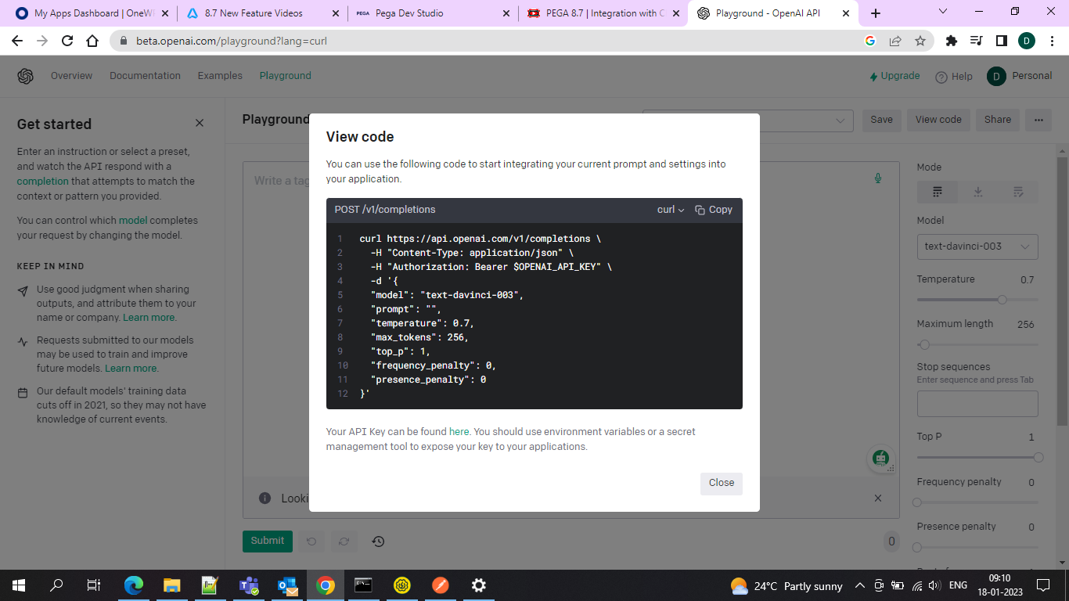

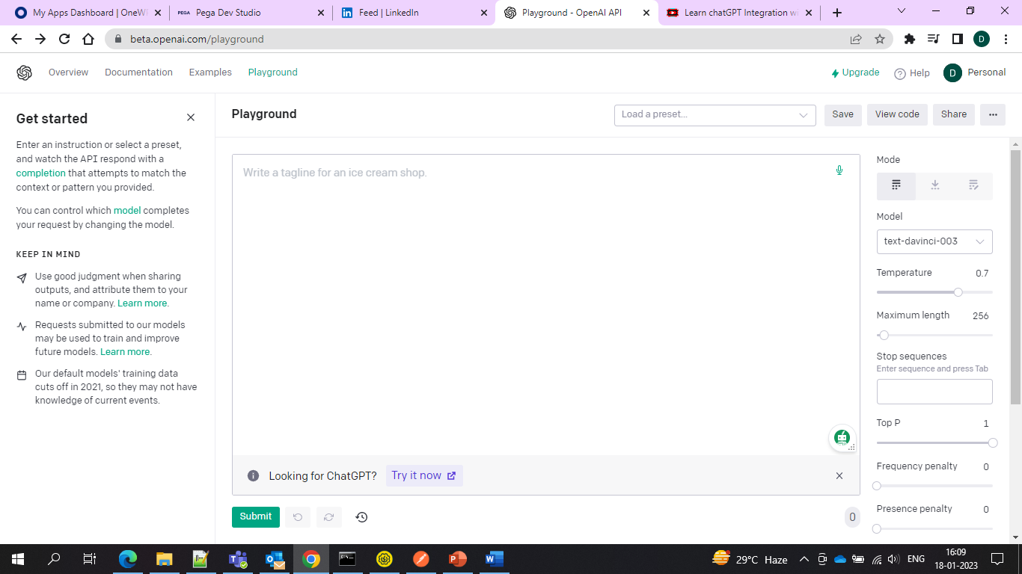

ma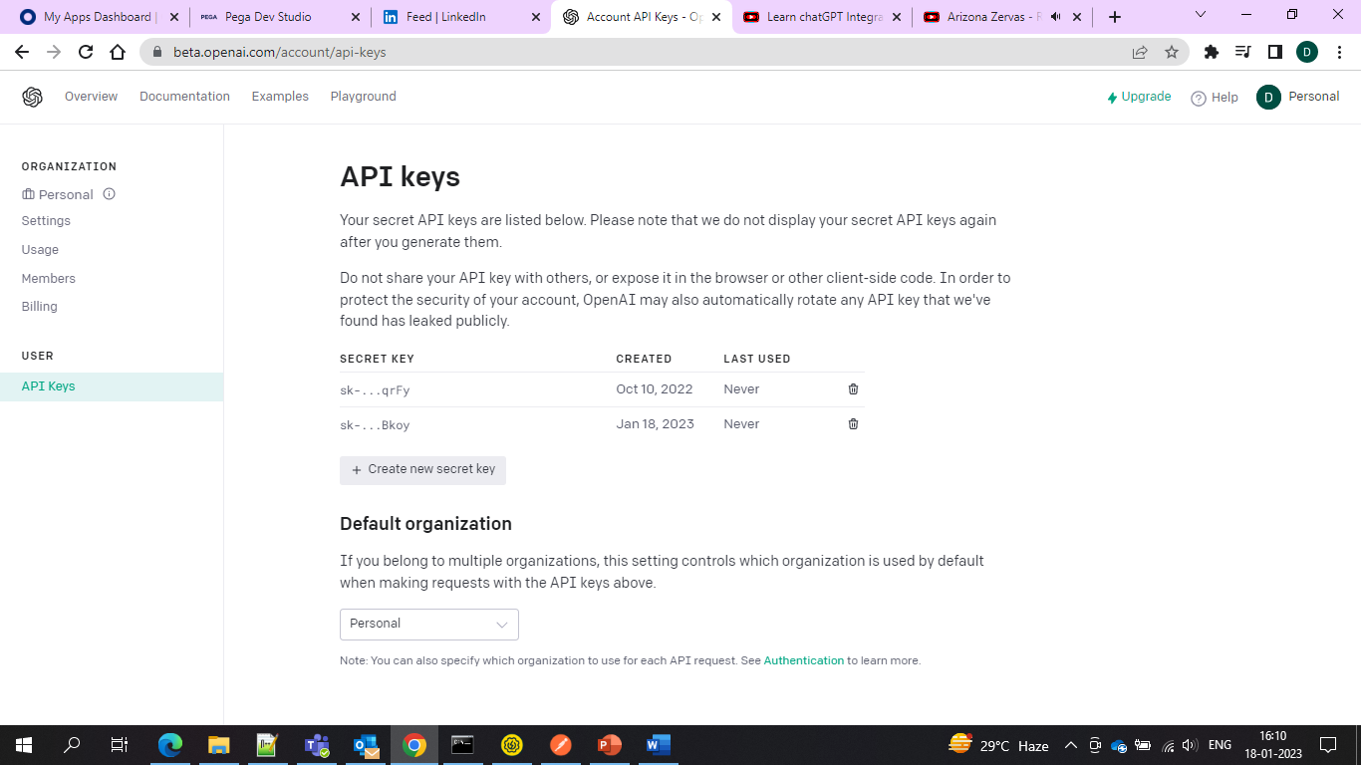

And then either use the existing one or creates a new key and then go to the postman to test it

First, give the Body of the code which you copied and then in the headers authorization give the API key which you copied and then add the Bearer prefix to it and then give it in the postman and hit send. Then you would get results.

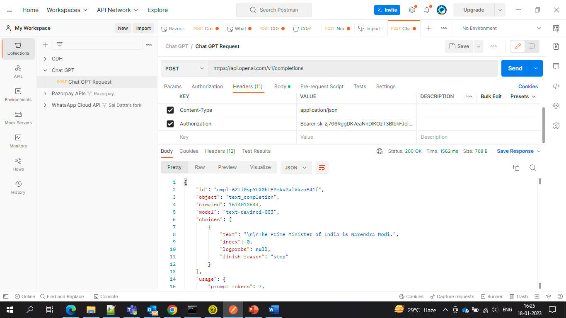

And now the same thing we are applying in Pega

Create REST integration

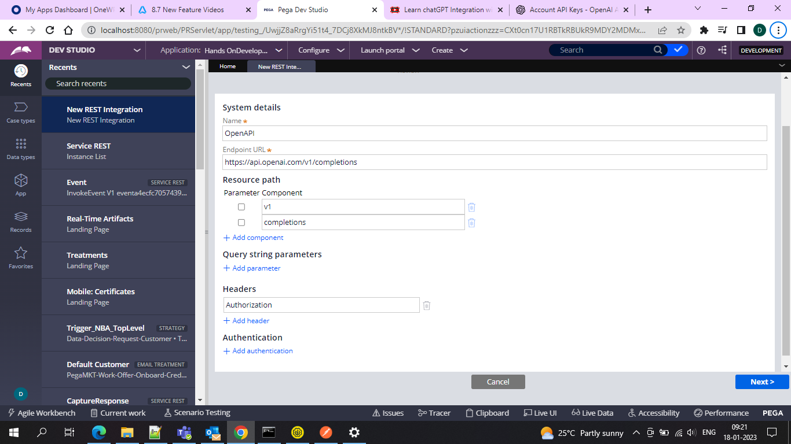

And use the Post method

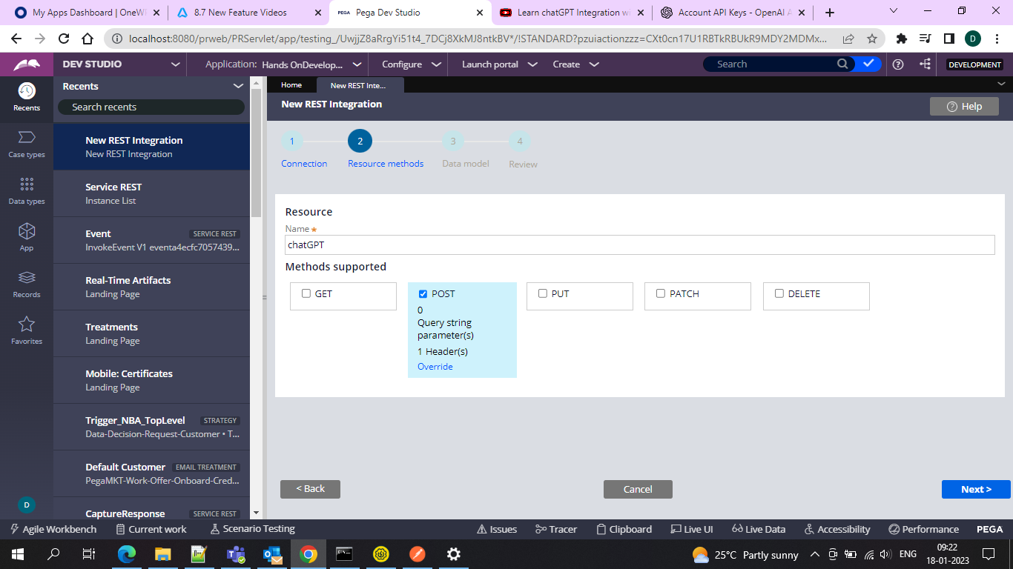

And after that add a rest response

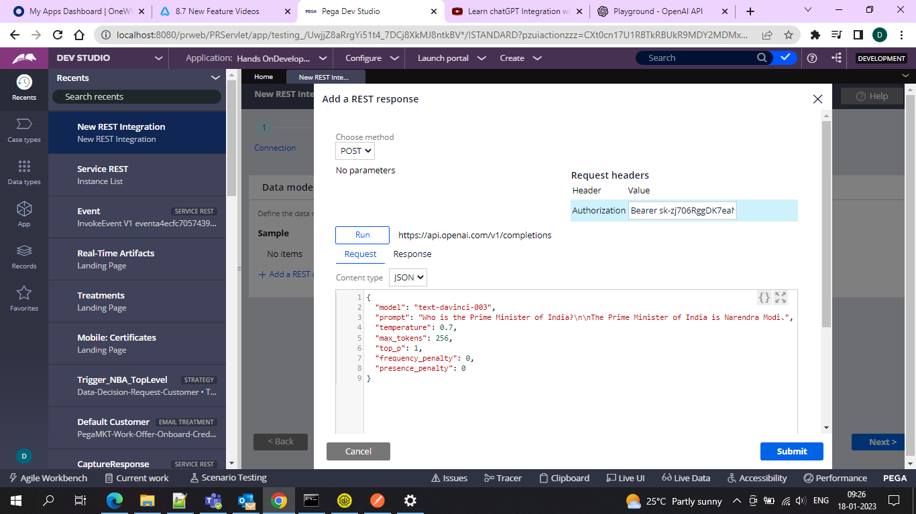

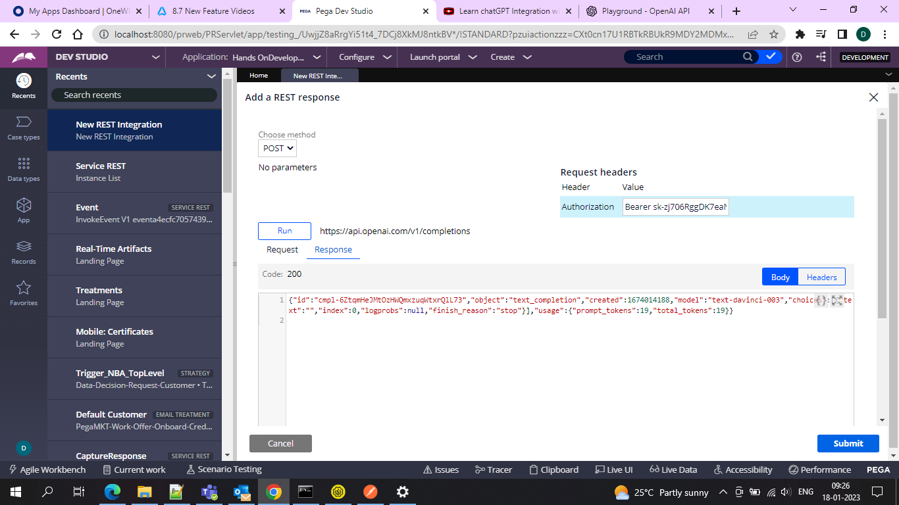

And after that, we need to go for the Creating of the rest service.

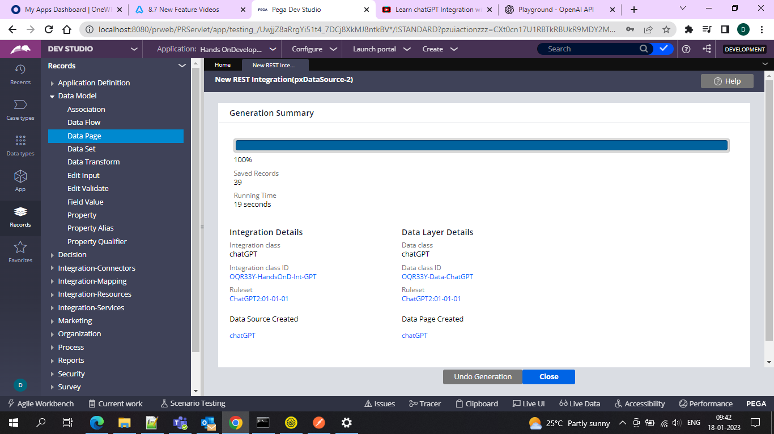

And after that run the data page that would be created

And give a parameter prompt so that you can pass dynamically

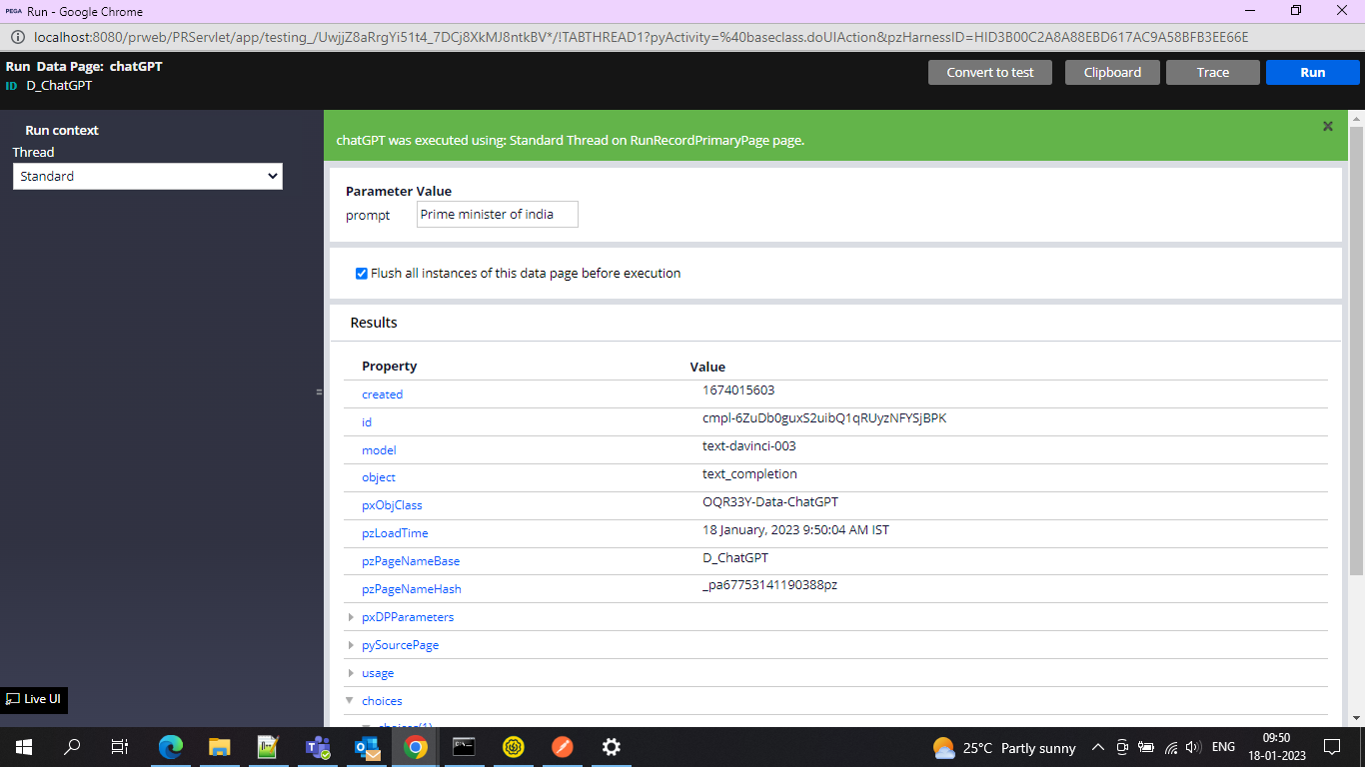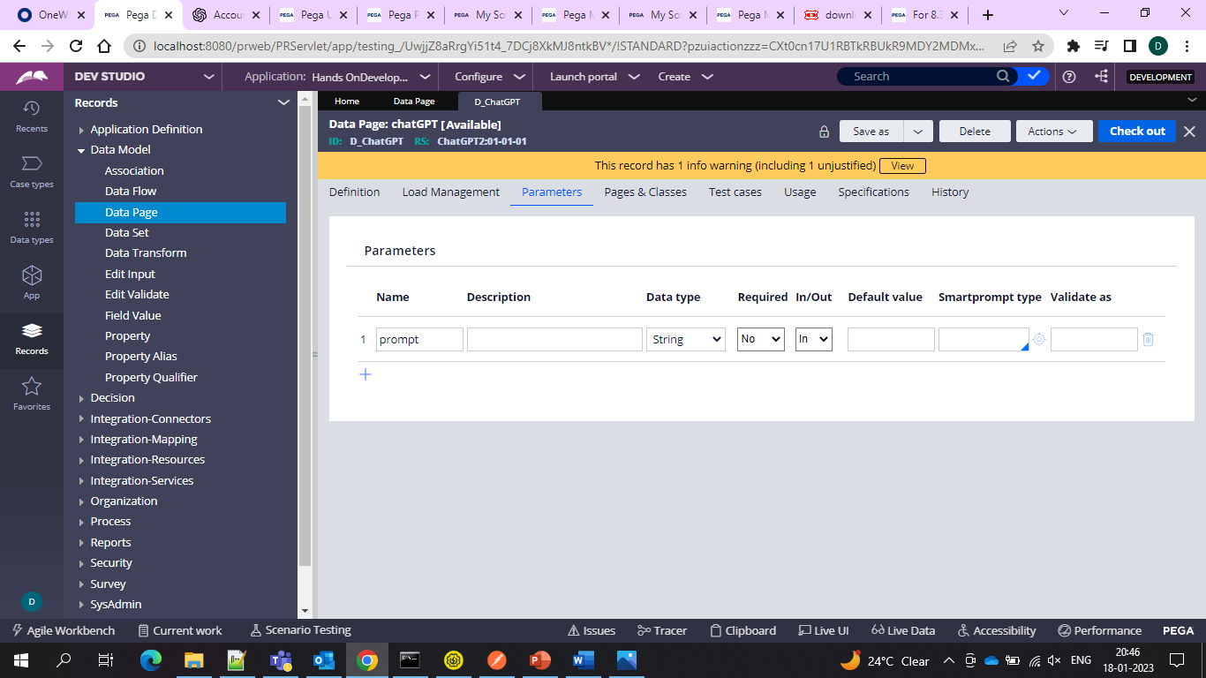

Because in the request DT we have this one where we would get the prompt value which since I want to pass it dynamically so using Param for the DT and Data Page

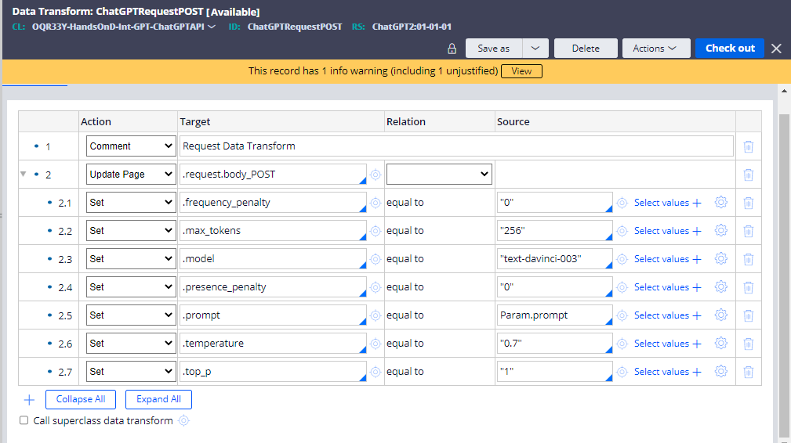

And let’s run the data page and check where the results are displayed and stored so we are observing that under the choices and under that under text property we are having the values stored

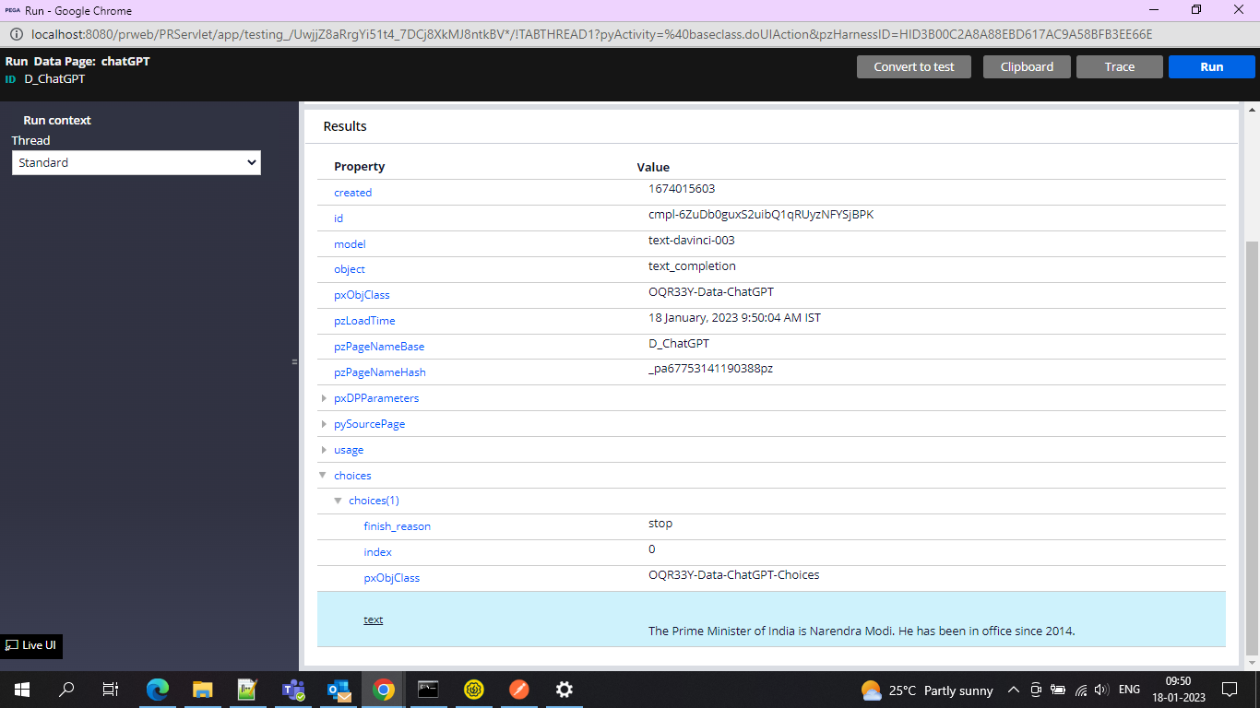’and now let’s show in the UI

So created one case type 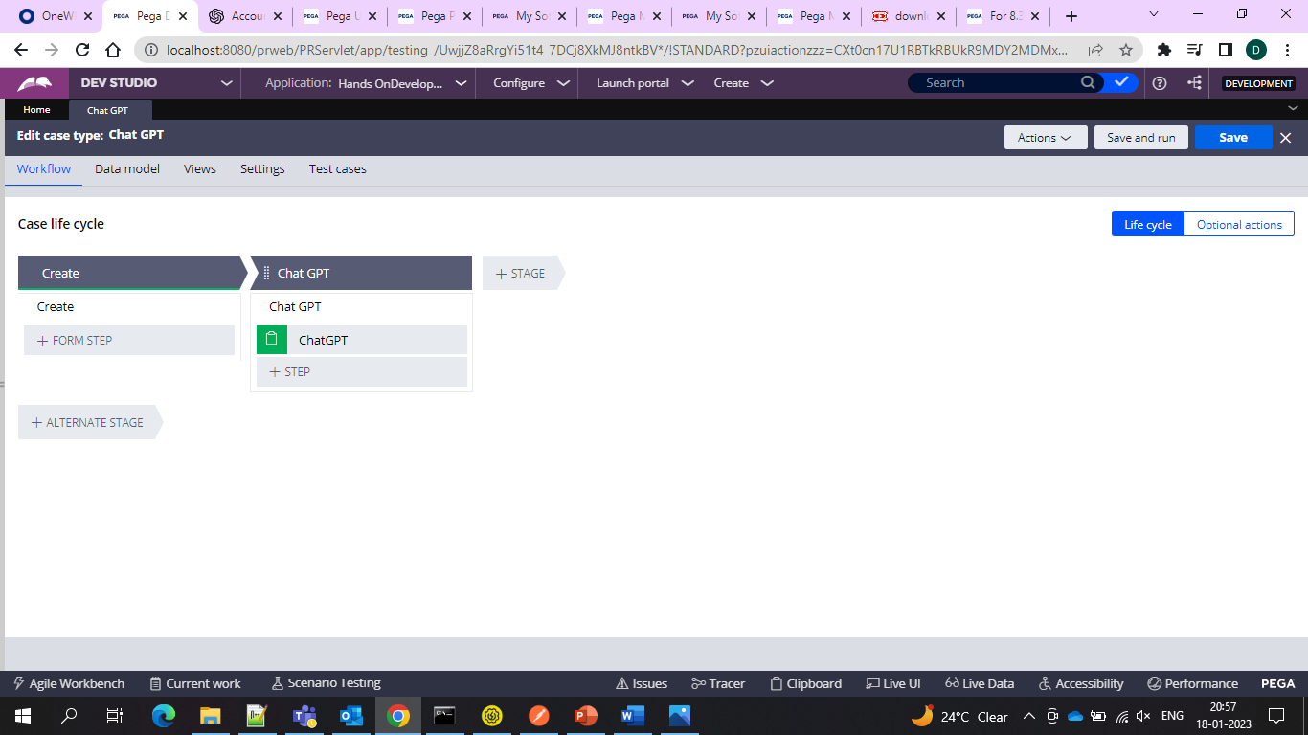

And inside that configured section

And inside that associated a text input and associated it with pyNote to capture the prompt

And one more text area for the response and associated it with the pyTestString property to capture the response

And configured one button and then using DT and running on it to refresh and display the result

The DT would be like this

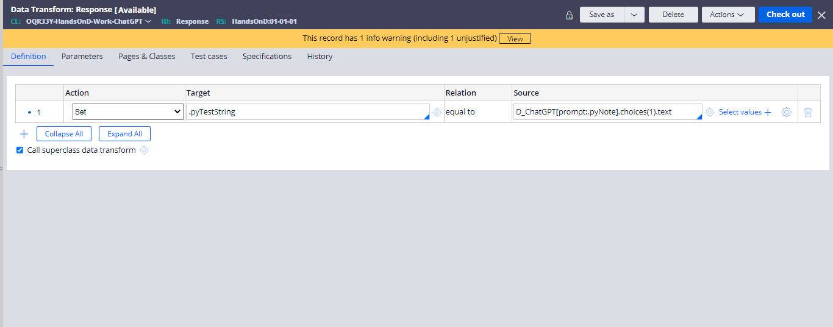

So here the property pyTestString is capturing the response so assigning/setting the value from the Data page

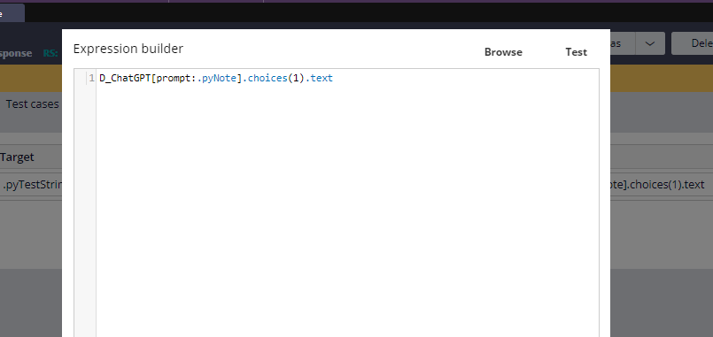

And here in the data page the prompt is capturing the response and that we assigned to pyNote and under the prompt we are getting results under choices which is a page list and under that we see the results so that is why this expression. Since everytime we get one result so using choices(1) that is page list(1)

And the same we applied on the button in the section.

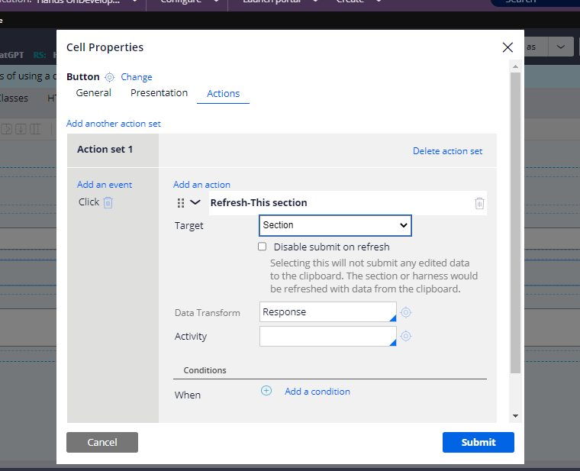

And in the section we are using table layout and also are passing the pyNote to the Prompt and pyTestString to the response field and one button to run the DT and display the result

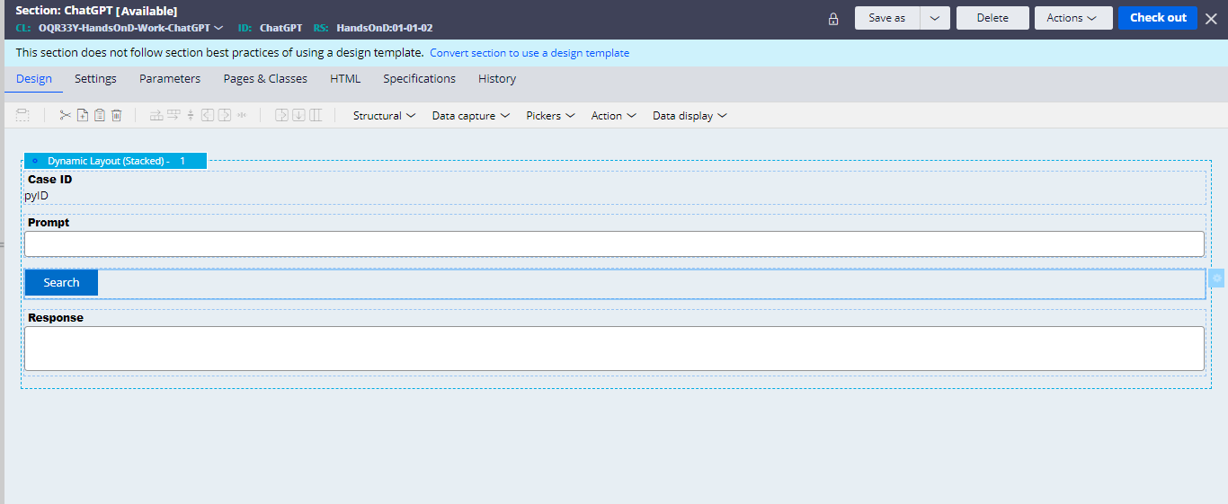

And the configuration is done and let’s see the result

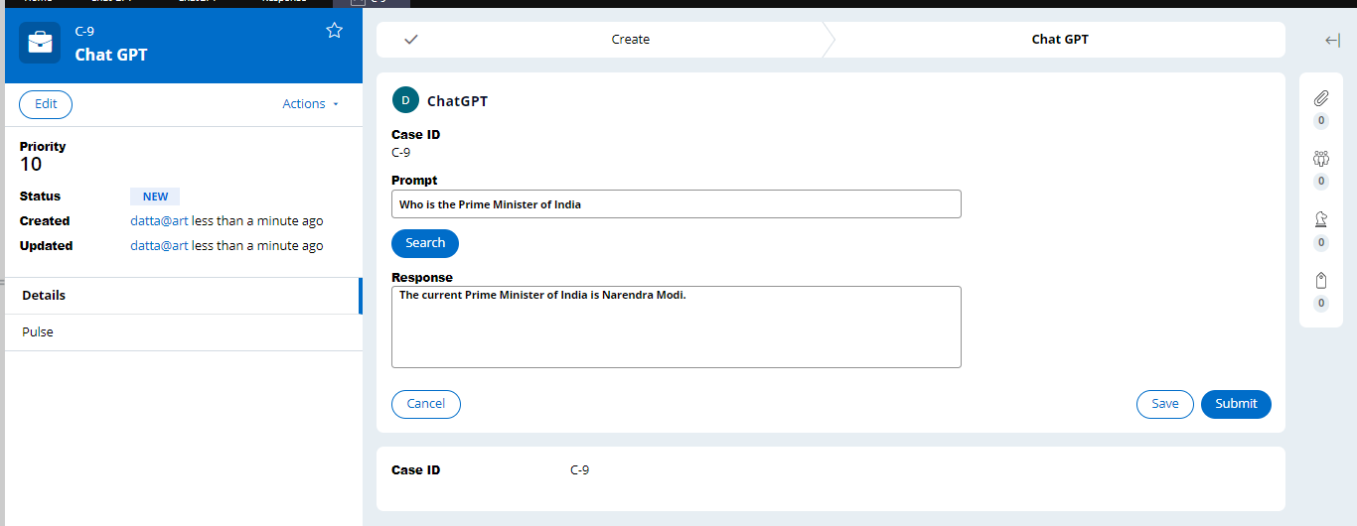

And hence the result.